Weather Station & Temperature controlled AC

Project By:

Class:

BS(AI) 4th Morning A

Muhammad Salman

Muhammad Usman Zafar

Syed Faseeh ul Hassan

--------⁕-------------------------------------- ⁕-------

Problem Statement

An IOT and AI Project for Live and Future Weather Forecasting based on Machine Learning Techniques.

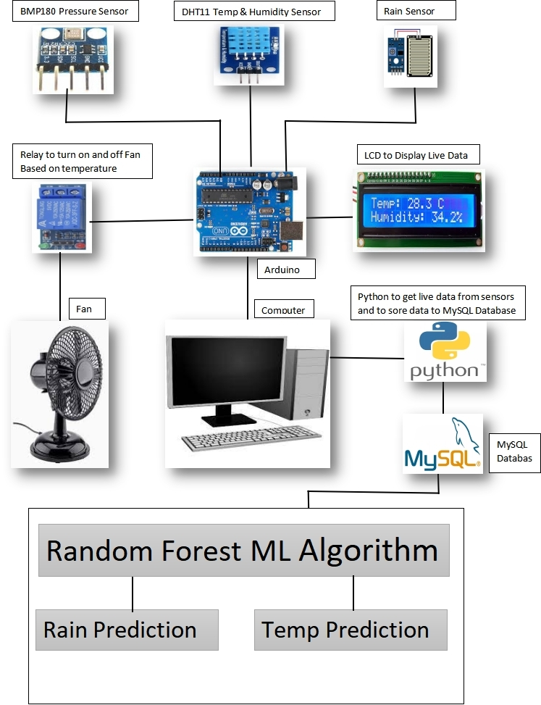

Tools And Material Used

Hardware

* Arduino Uno
* DHT11 Temperature and Humidity Sensor
* BMP180 Pressure Sensor
* Rain Sensor
* Relay Module

Other Tools

* Arduino IDE
* Python
* VS code
* Jupyter Notebook
* My SQL Server
* Xampp Control Panel
* phpMyAdmin

Languages and Libraries Used

* Python
* C++
* SQL
* Pyserial
* MySQL-Python

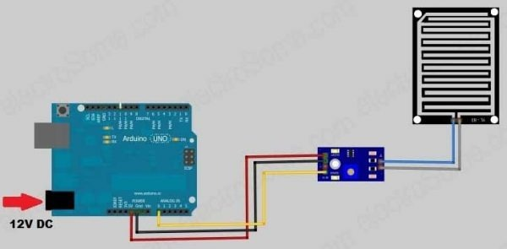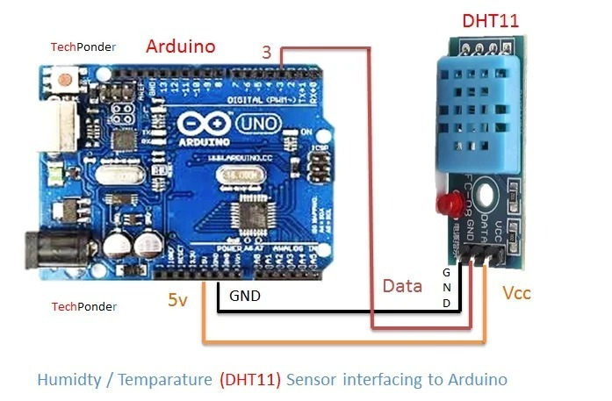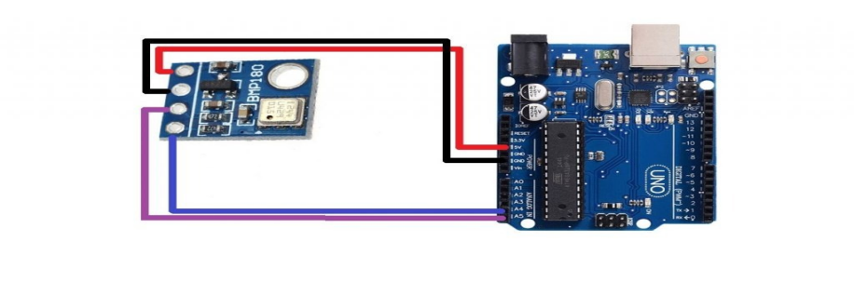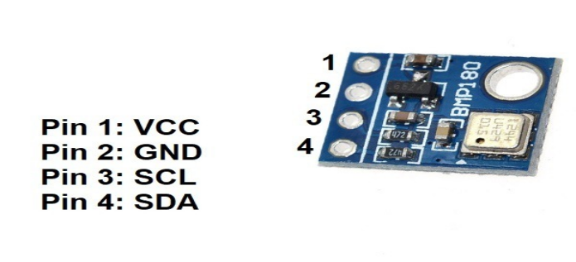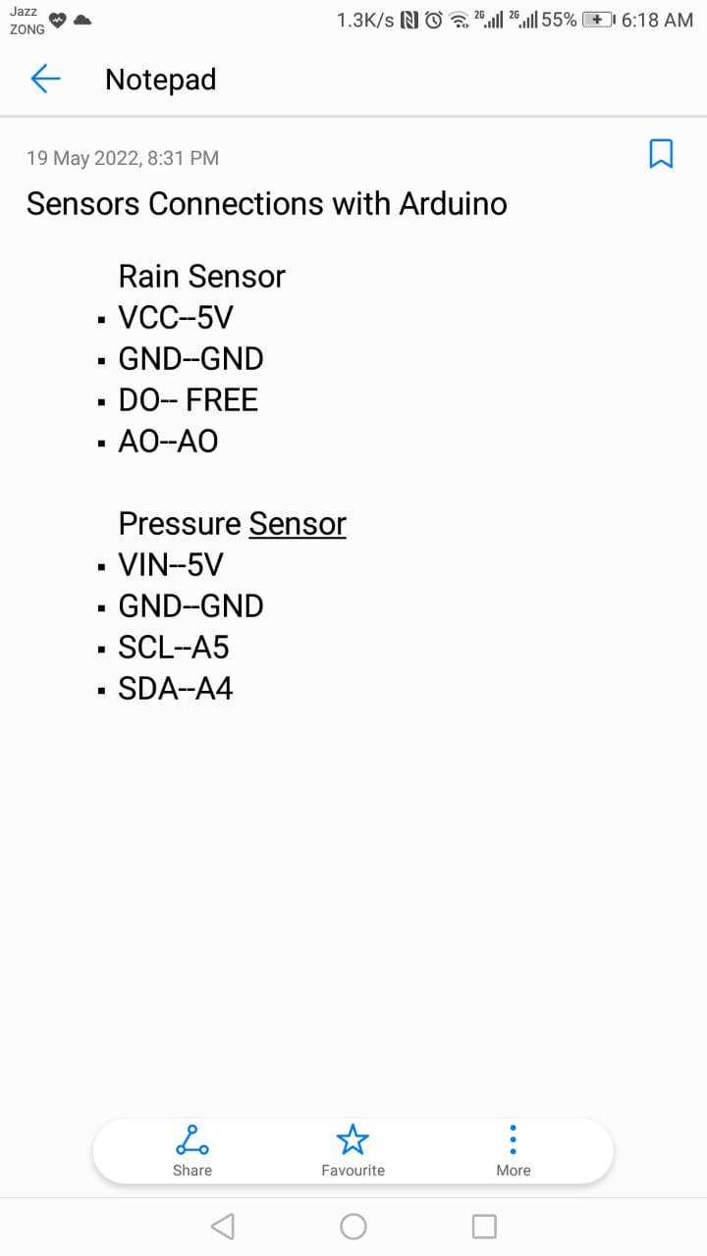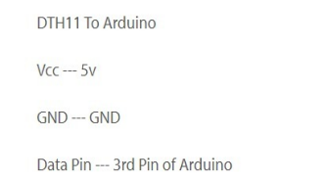

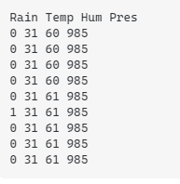Data From Arduino

Raining → 1 | Not raining → 0

Temperature in Celsius(C)

Humidity percentage(%)

Pressure in HectoPascal(hPa)

Data Analysis Techniques

* Artificial Neural Network(ANN)
* Random Forest Regression

Artificial Neural Network(ANN)

We have used ANN for rain prediction using three features: Pressure, Temperature, Humidity.

Random Forest Regression

We used Random Forest Regression for temperature prediction using three feature date.

Graph Against Minutes And Temperature Predicted

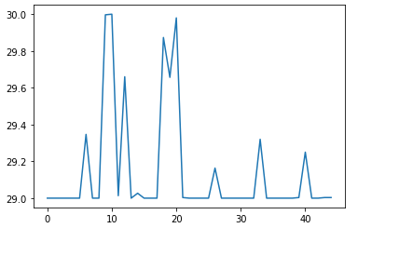

Temperature Controlled AC

We are using temperature parameter to control Air cooler or AC. When temperature increases from specific range the AC turns ON and when it goes below specific range the AC turns OFF.

For this we used relay module which turns off and on the AC after getting signal from arduino.